UNITED WAY CAMPAIGN REPORT SHEET
Please enclose this report in an envelope with pledge forms, cash and checks. Thank you!

ORGANIZATION INFORMATION DATE_______________________________

Organization Name: Store Location/Number #:
Campaign Coordinator: Phone:
Campaign Coordinator’s Email Address:
Top Local Executive: Title:
Organization’s Mailing Address:
Number of Employees:

Organization Gift Information: | Pledge Amount | Cash or  Check(s) Enclosed | Coord’s  Initials | UW Rep’s  Initials | Reconciling
ORG. GIFT Please Bill Me: □ Yes □ No
EMPLOYEE MATCH Please Bill Me: □ Yes □ No

Employee Gift Information: | Number of Givers | Total | Coord’s  Initials | UW Rep’s  Initials | Reconciling
CASH
CHECKS
PAYROLL DEDUCTION
Effective Date ___-___-_____
(Enclose white copy of pledge form)
BILLED
CREDIT CARDS
FUNDRAISERS | N/A
TOTAL:

Thank you!
Thank You!
Thank You for Living United!
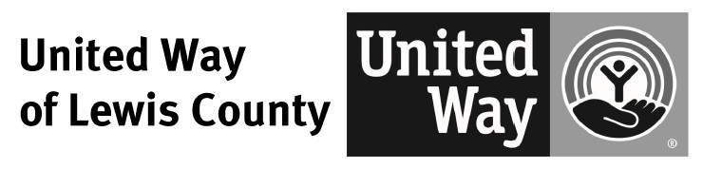
For more information, please contact:
Angela French, Development Director
Tel. 360.748.8100 FAX 360.748.8222
development@lewiscountyuw.com

